

**Customer Requirement Specifications (CRS)**

***Human Resource Management (HRM)***

***ERP Solution for Samuda Chemicals Ltd.***

1. Document Information

|  |  |
| --- | --- |
| Document Name | CRS of Human Resource Management (HRM) |
| Document Author | Kamrun Nahar |
| Document Version | 1.0 |
| Release Date |  |

|  |  |
| --- | --- |
| Review by | Md. Mahfuzur Rahman |
| Review Date | Jan 25, 2017 |
| Approved By | Matiar Rahman |
| Approval Date | Jan 26, 2017 |

Signed on behalf of Signed on behalf of

Samuda Chemicals Ltd. Genweb2 Limited

Name: Name:

Designation: Designation:

Date: Date:

**______________________________ ______________________________**

Signature Signature

1. Document History

|  |  |  |  |  |  |
| --- | --- | --- | --- | --- | --- |
| A=Added, M=Modified, D=Delete | | | | | |
| **Version No** | **Date** | **Section No** | **A/M/D** | **Description of Change** | **Author** |
| 1.0 | 25-Jan-2017 |  | A | Initial | Kamrun Nahar |
|  |  |  |  |  |  |
|  |  |  |  |  |  |

**Contents**

A. Document Information 2

B. Document History 3

**3. Sub Module and Its feature Description** 5

**3.3 Training Process** 5

**3.3.1 Module Overview** 5

**4. To be Determined** 7

# **3. Sub Module and Its feature Description**

## **3.3** **Training Process**

### **3.3.1 Module Overview**

The training module enables businesses to conduct internal or external employee training. The Training Center module includes following features:



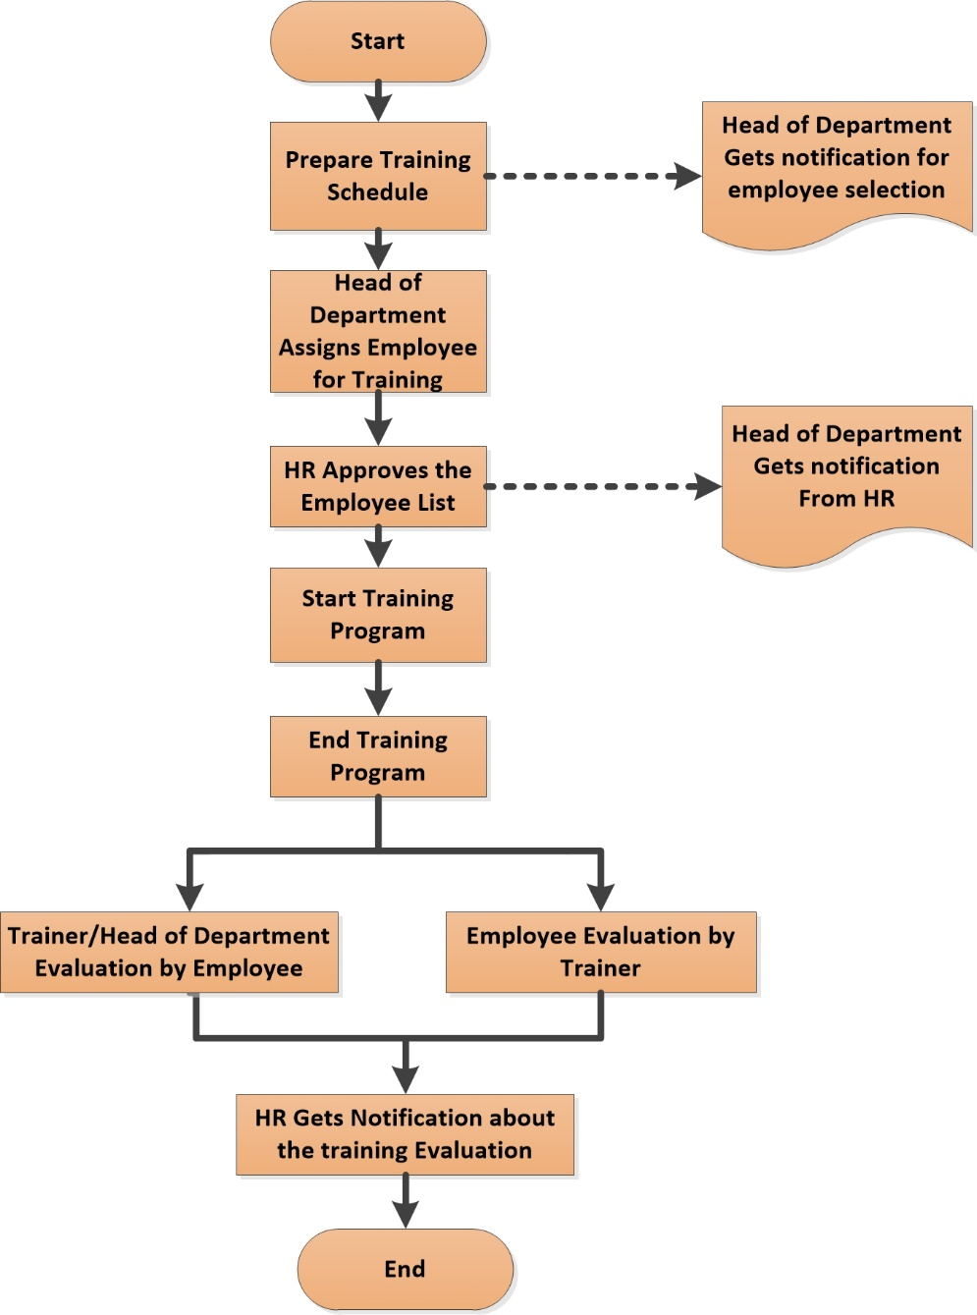

**Fig:** Training Process

## **4. To be Determined**

1. ISO 9001 related reports are not implemented within this phase. We will cover in next phase.

Signed on behalf of Signed on behalf of

Samuda Chemicals Ltd. Genweb2 Limited

Name: Name:

Designation: Designation:

Date: Date:

**______________________________ ______________________________**

Signature Signature